COIT11238 – TCP/IP Principals and Protocals

Term 1, 2026

Week 1

Name: Elish Niraula
ID: 12313870
Lecturer / Tutor: Suresh Talam

In this week 1 I just learned how to use the GNS3 basics way to use nodes and many more things.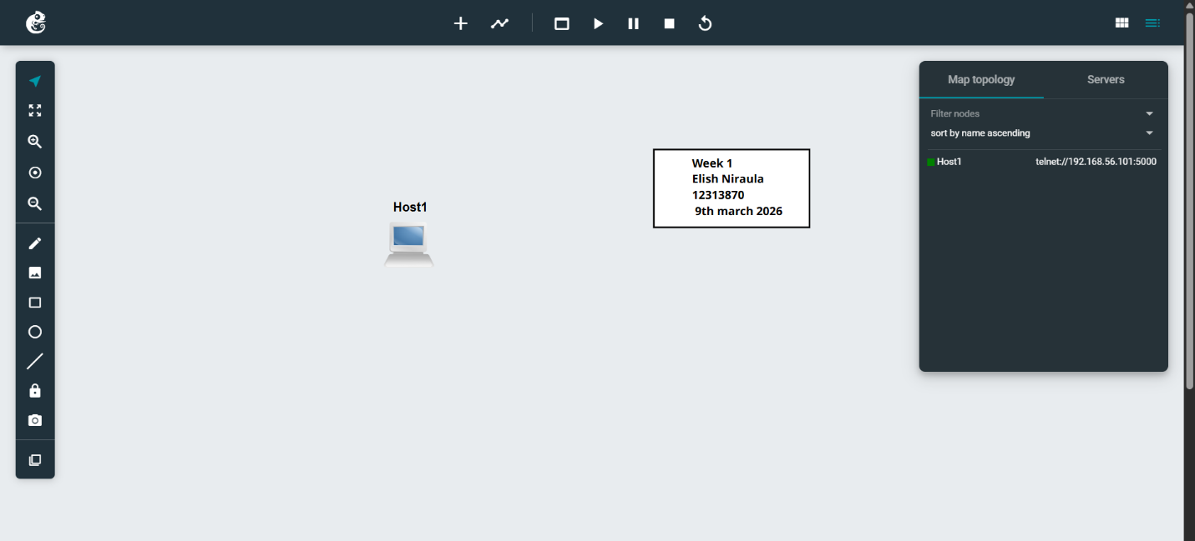
At first I added a host and config its ip address ansd start it.
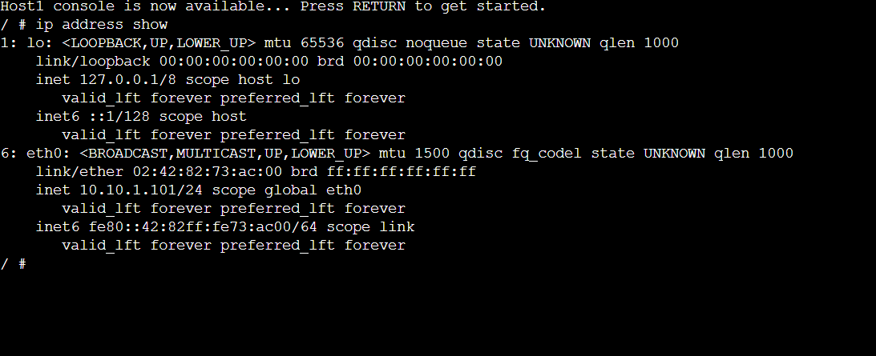
Apply the changes to the file, and then apply the configuration changes. Now start the node:
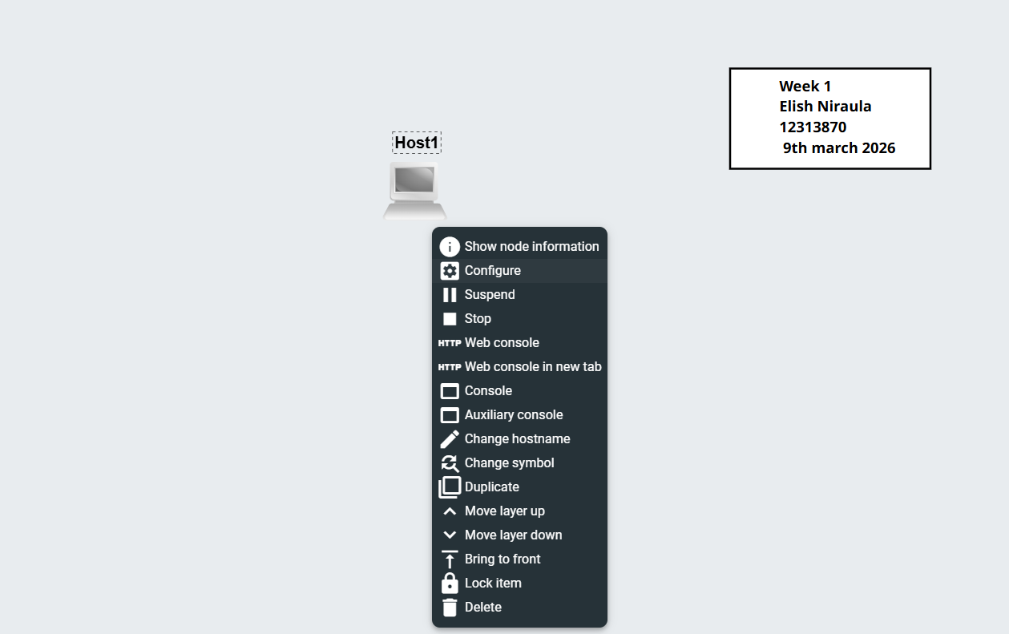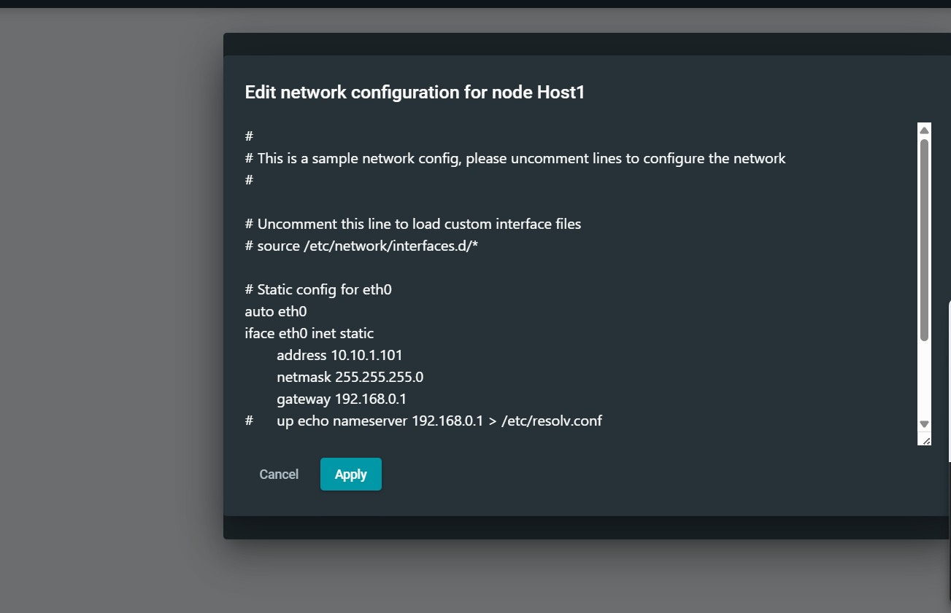
At last I stop the nodes and end the system to be run.

